TIES 452 (2014): Guidelines for the 3rd computer class demo
Your surname: Khandker
Your first name: Syed Ibrahim

Task 1: Underneath you see a graphical representation of the TBox part of an ontology. Please write it in Turtle notation using RDF Schema as the ontology language.
Namespaces are defined as following:
@prefix u: <http://www.jyu.fi/ontology#> .
@prefix rdfs: <http://www.w3.org/2000/01/rdf-schema#> .
@prefix xsd: <http://www.w3.org/2001/XMLSchema#> .
@prefix rdf: <http://www.w3.org/1999/02/22-rdf-syntax-ns#> .

Original file with images: http://users.jyu.fi/~olkhriye/ties452/demos/demo3/Ontology.ppt

Class hierarchy:
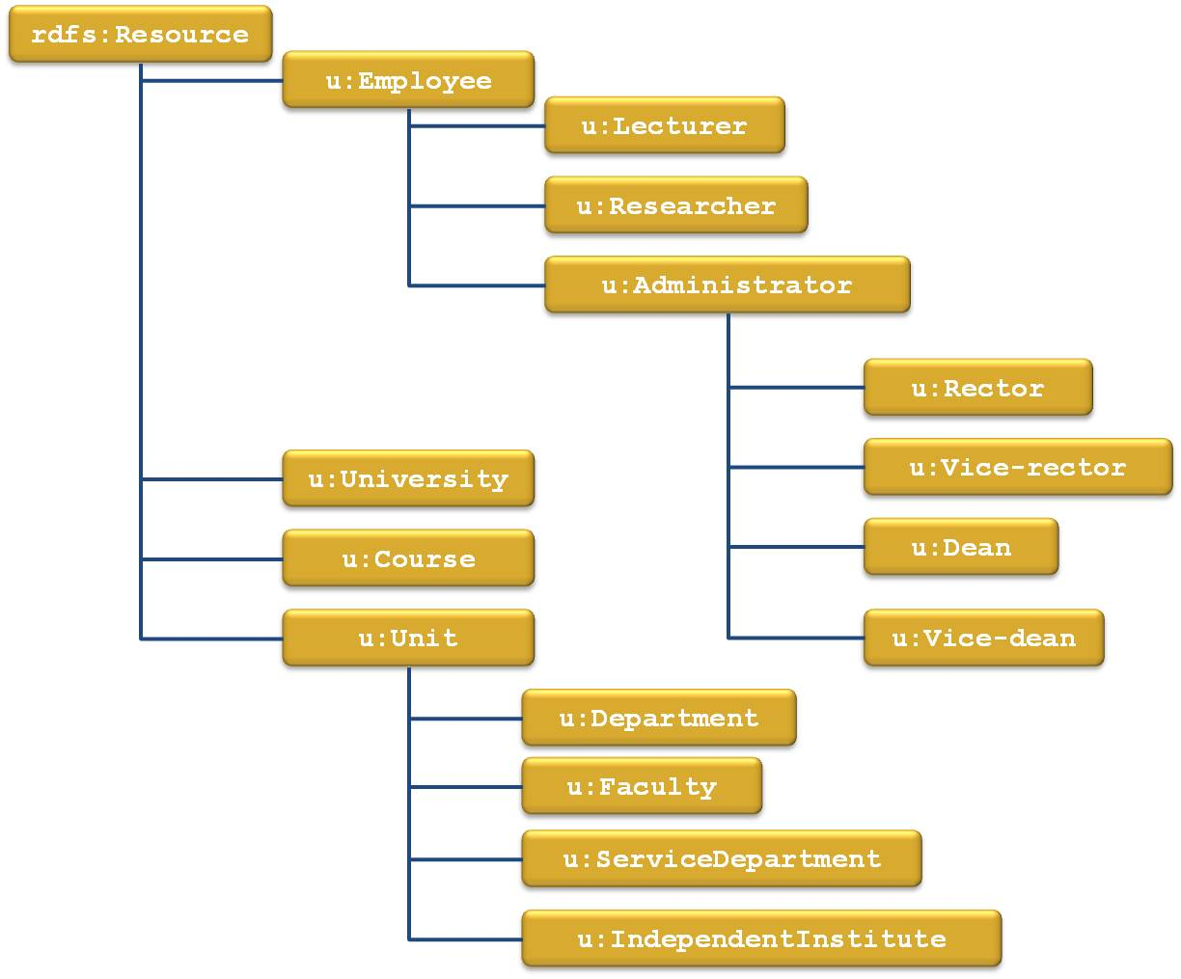

Properties (no hierarchy, all at the same level):
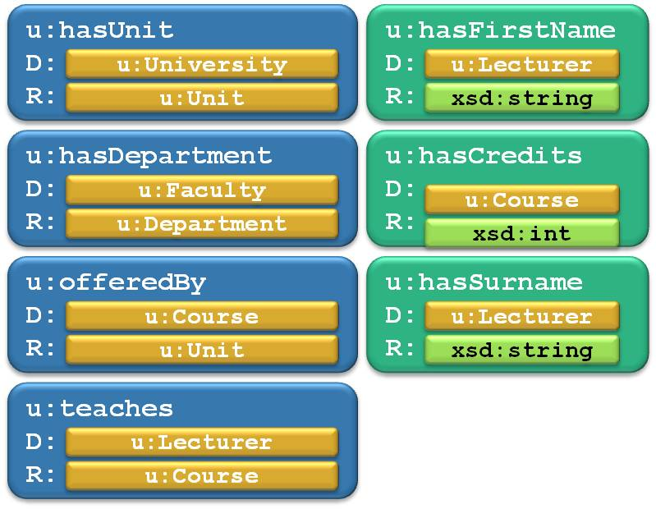

Your solution in Turtle:
Due to short space here I have added answer of question 1 as a txt file in the folder. File name question1.txt

Task 2: Below you can see an ontology written in RDFS. It contains both ABox and TBox. Underneath there are several statements written in a table. For each statement decide if it is correct according to the ontology or not. If the statement is correct, put X in the correct column. If it is incorrect, put X in the incorrect folder. Prefixes and namespace in the table are defined the same as in the ontology text area Ontology in Turtle.
Let’s assume that there is a reasoner that would detect hidden relationships, e.g. class-subclass relationship. Therefore take into account also derived statements, even though they are not explicitly defined.
Important: Your job is not to decide if the statement is true or false. Your job is to decide if the statement is formally correct according to the ontology.

Ontology in Turtle:
@prefix z: <http://zoo.com/animalOntology.rdfs#> .
@prefix rdfs: <http://www.w3.org/2000/01/rdf-schema#> .
@prefix xsd: <http://www.w3.org/2001/XMLSchema#> .
@prefix rdf: <http://www.w3.org/1999/02/22-rdf-syntax-ns#> .

z:Animal a rdfs:Class .
z:Mammal a rdfs:Class ;
rdfs:subClassOf z:Animal .
z:Primate a rdfs:Class ;
rdfs:subClassOf z:Mammal .
z:Bird a rdfs:Class ;
rdfs:subClassOf z:Animal .
z:Fish a rdfs:Class ;
rdfs:subClassOf z:Animal .

z:hasWingSpan a rdf:Property ;
rdfs:domain z:Bird ;
rdfs:range xsd:float .
z:hasFingers a rdf:Property ;
rdfs:domain z:Mammal ;
rdfs:range xsd:int .
z:hasLatinName a rdf:Property ;
rdfs:domain z:Animal ;
rdfs:range xsd:string .
z:eats a rdf:Property ;
rdfs:domain z:Animal ;
rdfs:range z:Animal .

z:eagle a z:Bird .
z:elephant a z:Mammal .
z:dolphin a z:Mammal .
z:homoSapiens a z:Mammal .

Statements:
Statement | Correct | Incorrect
z:eagle z:hasLatinName "Aquila chrysaetos" | X
z:dolphin z:hasLatinName "15.3"^^xsd:float |  | X
z:eagle z:eats z:dolphin | x
z:eagle z:hasWingSpan "4.3"^^xsd:int |  | x
z:homoSapiens z:hasFingers "5"^^xsd:int | x
z:eagle z:hasFingers "3"^^xsd:int |  | x
z:eagle z:hasWingSpan "5000"^^xsd:float | x
z:elephant z:hasFingers "8"^^xsd:int | x

Task 3: Write an ontology using RDF Schema. You can choose any domain you want.
Your ontology in Turtle:
@prefix r: <http://www.room.com/ontology#> .
@prefix rdfs: <http://www.w3.org/2000/01/rdf-schema#> .
@prefix xsd: <http://www.w3.org/2001/XMLSchema#> .
@prefix rdf: <http://www.w3.org/1999/02/22-rdf-syntax-ns#> .

r:Room a rdfs:Class .

r:Door a rdfs:Class ;
rdfs:subClassOf r:Room .

r:Window a rdfs:Class;
rdfs:subClassOf r:Room.

r:Wall a rdfs:Class ;
rdfs:subClassOf r:Room .

r:Floor a rdfs:Class ;
rdfs:subClassOf r:Room .

r:Lock a rdfs:Class ;
rdfs:subClassOf r:Room.

r:Curtain a rdfs:Class ;
rdfs:subClassOf r:Room.

r: Ceiling a rdfs:Class ;
rdfs:subClassOf r:Room .

r:Windowglass a rdfs:Class ;
rdfs:subClassOf r:Window .

r:Wallpaint a rdfs:Class ;
rdfs:subClassOf r:Wall .

r:hasLock a rdf:Property;
rdfs:domain r:Door;
rdfs:range r:Lock.

r:hasCurtain a rdf:Property;
rdfs:domain r:Window;
rdfs:range r:Curtain.

r:hasCeilingFan a rdf:Property;
rdfs:domain r:Ceiling;
rdfs:range xsd:int.

r:hasFloormat a rdf:Property;
rdfs:domain r:Floor;
rdfs:range xsd:int.

Task 4: Download and install Protégé 4.x (5.x). Create a new ontology in Turtle format and name it as myOntology. This will generate file myOntology.owl that you return as demo results. Create ontology of your own choice (any domain). The ontology must contain the following:
- At least 15 classes in total
  - At least one class defined as enumeration of its individuals
  - At least one class defined using property cardinality restrictions
  - At least one class defined using property range restrictions
  - At least one class defined as a union of classes
  - At least one class defined as an intersection of classes
  - At least one class defined as a complement of some class
- At least 5 object properties in total
- At least 5 datatype properties in total
- The ontology must be consistent
After the ontology is complete, perform a consistency check. Add the Pellet reasoner and perform consistency check:
- go to “Reasoner” menu;
- under “Configure…” select “Plugins” tab;
- in “Plugin registry” area press the button “Check for downloads now”, select and install Pellet plugin;
- perform consistency check selecting the Pellet reasoner and starting it from the “Reasoner” menu.

Tips: First think about the domain you want to model. Then write down the classes you want to assert. Try to form a class hierarchy. After that, think about the object and datatype properties.

Task 5: Open a text editor and try to annotate at least 5 individuals using concepts from the ontology (define relations between individuals). Eventually, save these 5 or more individuals in Turtle notation into and name the file individuals.rdf. Copy this file to the same folder where you have your ontology. Now you should have these 2 files in the result folder.

Task 6: Copy file with ontology and rename it to myOntology_and_Individuals.owl Open it in a text editor and imbed previously created individuals into ontology. Open the file in Protégé and go to Individuals tab and check if the individuals are properly annotated. If yes, then you can add this file to the same result folder and send your 3 files as Demo result.

Files to include in the demo results:
- Demo3-instructions.doc (this file)
- myOntology.owl
- individuals.rdf
- myOntology_and_Individuals.owl
Send the demo results as an archive file (*.zip or *.rar) to lecturer (oleksiy . khriyenko @ jyu . fi) before the day of the next Demo session.

